**First-person perspective 3D snake game**

LIU Qinhan, 20328953

LIU Ji, 20327997

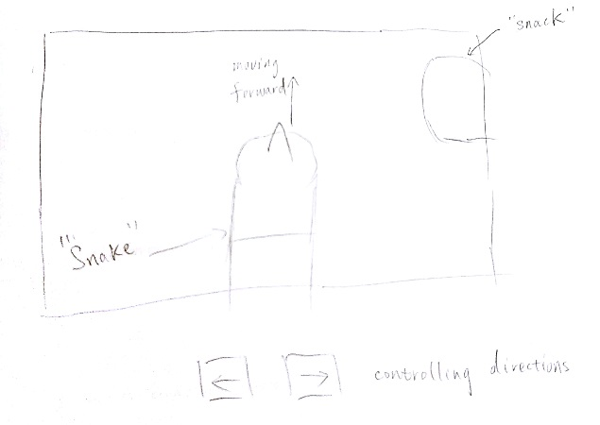**Introduction**:

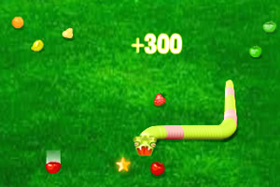

We revise the 3D snake game into a first-person perspective game, with the perspective camera above the snake head.

**Controls:**

Use left and right arrows to rotate the moving direction of the snake

Use spacebar to pause and continue the game

**Shading:**

1. Day mode:

Simulate the lighting conditions of sun rising and falling

1. Night mode:

Ambient light for the environment

Point light source right above the head of the snake and the lightness decays as distance increases

Constant point light at the position of the snack

1. Shadow and shading of the snake and the snack should be taken care of as the positions of light sources change
2. Special lightning effects when “eating” the snack and at the winning and losing of the game
3. Texture of elements in the whole game including walls, bricks, snake and snack

**Vertex:**

1. When the snake eats the snack, its body extends and the eating motion of its head is simulated.
2. The transition of the snake position (move forward, turning left or right)

**Extension:**

“Snake in a box”: the snake climbs the wall as it reaches the boundary, all 6 faces